A System Design Project Report on

**Nectar Of Service  
(Donation Campaigns)**

**Submitted in partial fulfillment of the degree of  
Bachelor of Computer Applications**

**VI Semester**

Submitted by

**Astitv Gangwar (213501029)  
Chirag Arora (213501036)  
Hardik Khatri (213501068)**

Under the Supervision of  
**Dr. Krishna Kumar Bohra**

Faculty of Computer Science



**Faculty of Computer Science  
Lachoo Memorial College of Science & Technology (Autonomous)**

**Jodhpur**

*2024*



##### **Faculty of Computer Science**

**Lachoo Memorial College of Science & Technology (Autonomous)**

# CERTIFICATE

This is to certify that the System Design Project entitled

**Nectar Of Service (Donation Campaigns)**

has been designed and developed by

**Astitv Gangwar  
Chirag Arora  
Hardik Khatri**

in partial fulfillment of the degree of BCA VI Semester Examination 2023, under our supervision and guidance.

**Prof. (Dr.) Priyadarshi Patni Dr. Krishna Kumar Bohra**

Director Assistant Professor,

Faculty of Computer Science Faculty of Computer Science

Date: 12/05/2024

**Acknowledgement**

The satisfaction and euphoria that accompany the successful completion of any task would incomplete without the mention of the people who made it possible, whose constant guidance and encouragement crowned our effort with success.

We express our sincere gratitude to our Principal Prof (Dr.) Rohit Jain for providing facilities.

We wish to place on record our grateful thanks to Prof. (Dr.) Priyadarshi Patni providing encouragement and guidance.

Also we thank the faculty members of the Computer Science department whose suggestions enabled us to surpass many of the seemingly impossible hurdles.

We also thank our guides and lastly we thank everybody who has directly or indirectly helped us in the course of this project.

**Astitv Gangwar (213501029)  
Chirag Arora (213501036)  
Hardik Khatri (213501068)**

**Contents**

|  |  |
| --- | --- |
| 1. Introduction | 1 |
| 1. Recognition of Need | 2 |
| 1. Existing System with Limitations | 3 |
| 1. Proposed System with Advantages | 6 |
| 1. Process/Working | 9 |
| 1. Feasibility Study | 18 |
| 1. Data Flow Diagrams | 22 |
| 1. E R Diagram and Database Tables | 24 |
| 1. Project Design (Screenshots) | 26 |
| 1. Future Enhancement | 41 |
| 1. Conclusion | 43 |
| 1. References | 44 |
| Appendix | 45 |

**1. Introduction**

“Nectar Of Service" is a dynamic digital platform designed to revolutionize the landscape of charitable giving by providing a centralized hub for managing and monitoring donation campaigns. Inspired by the impactful initiatives of renowned organizations such as The Akshaya Patra Foundation and ISKCON Bangalore, our project aims to empower organizations to connect with donors effectively and drive meaningful social change.

Our primary objective is to simplify the donation process for both administrators and donors through an intuitive and user-friendly interface. Administrators will benefit from robust features for efficient campaign management, including options for tracking donations and analyzing campaign performance. Donors, on the other hand, will enjoy a seamless experience with interactive features like progress trackers and real-time updates on campaign achievements.

In addition to facilitating financial contributions, "Nectar Of Service" aims to inspire action beyond donations by fostering community engagement and collaboration. Features such as social media integration, a community forum, and opportunities for donor recognition will encourage active participation and amplify the impact of collective efforts.

Powered by a comprehensive toolkit including HTML, CSS, JavaScript, PHP, MySQL, and various APIs, "Nectar Of Service" offers a range of functionalities to enhance user experience and ensure data security. From campaign creation and management to automated email notifications and real-time donation tracking, our platform is equipped with key features to drive engagement and promote transparency.

**2. Recognition of Need**

In the spirit of organizations like ISKCON Bangalore and The Akshaya Patra Foundation, there arises an urgent need for a transformative platform that embodies their ethos of service and community empowerment. These esteemed organizations have demonstrated the profound impact that can be achieved through dedicated service and collaborative efforts, setting a precedent for meaningful engagement in social causes

However, despite their remarkable accomplishments, there remains a persistent need to enhance the efficiency and accessibility of donation management processes. Traditional methods often lack the agility and transparency required to fully leverage the collective power of donors and organizations. As such, there is a pressing demand for a modern, centralized platform that not only simplifies the donation process but also fosters deeper connections between stakeholders.

The current landscape of donation management systems is characterized by fragmentation and inefficiency, with organizations grappling with disparate tools and resources. This fragmented approach not only impedes effective campaign management but also hampers the ability to provide donors with real-time updates and insights into the impact of their contributions.

Moreover, donors today seek more than just a transactional relationship with the causes they support. They yearn for transparency, accountability, and opportunities for meaningful engagement. By addressing these fundamental needs, a centralized platform can redefine the dynamics of charitable giving, empowering both organizations and donors to create lasting social change.

In this context, "Nectar Of Service" emerges as a beacon of innovation and collaboration, inspired by the visionary leadership of organizations like ISKCON Bangalore and The Akshaya Patra Foundation. By offering a unified platform that integrates robust features for campaign management, donor engagement, and community building, we seek to honor their legacy of service while charting a new course towards greater impact and inclusivity. Through "Nectar Of Service," we aspire to catalyze a movement of compassion, unity, and collective action, in alignment with the noble ideals espoused by our esteemed predecessors.

**3. Existing System with Limitations**

In the landscape of donation management and campaign coordination, the current systems, though well-intentioned, are fraught with challenges and limitations that hinder their efficacy in fostering meaningful social impact. These limitations span various dimensions, encompassing organizational, technological, and user experience aspects. By dissecting these shortcomings, we can better appreciate the pressing need for innovative solutions that transcend the constraints of the status quo.

**1. Fragmentation and Complexity:**

The prevailing ecosystem of donation management is marked by fragmentation and complexity, with organizations often relying on a patchwork of disparate tools and platforms for various aspects of campaign coordination. This fragmented approach not only introduces inefficiencies but also exacerbates administrative burdens, as administrators must navigate multiple interfaces and systems to manage campaigns effectively. The lack of integration and interoperability among these systems further compounds the challenge, hindering seamless data flow and collaboration between stakeholders.

**2. Lack of Transparency:**

Transparency is the cornerstone of trust and accountability in the realm of charitable giving. However, existing systems often fall short in providing real-time updates and comprehensive insights into campaign progress and fund utilization. Donors are left in the dark regarding the impact of their contributions, leading to skepticism and hesitancy to engage further. Moreover, the opacity surrounding the allocation and distribution of funds undermines organizational credibility and erodes donor trust over time.

**3. Limited Donor Engagement:**

Donors today seek more than just a transactional relationship with the causes they support; they crave meaningful engagement and a sense of connection with the organizations they champion. Yet, existing systems often fail to foster genuine engagement beyond financial contributions. The lack of interactive features and personalized communication channels stifles opportunities for donor involvement and community-building, relegating donors to passive observers rather than active participants in the journey towards social change.

**4. Complexity in Campaign Management:**

Managing donation campaigns entails a multitude of tasks, ranging from campaign creation and donor tracking to performance analysis and reporting. Existing systems, however, often lack intuitive interfaces and robust features to streamline these processes effectively. Administrators are burdened with cumbersome workflows and manual tasks, detracting from their ability to focus on strategic initiatives and campaign optimization. The absence of comprehensive tools for campaign analytics and donor segmentation further complicates efforts to drive meaningful impact and maximize fundraising efficacy.

**5. Security Concerns:**

With the proliferation of online platforms for donation management, security vulnerabilities pose a significant threat to the integrity of donor data and financial transactions. Existing systems may lack robust security measures to safeguard against cyber threats such as data breaches, identity theft, and fraudulent activities. The absence of encryption protocols, multi-factor authentication, and secure payment gateways exposes donors and organizations to potential risks, undermining confidence in the platform's reliability and integrity.

**6. Scalability Challenges:**

As organizations aspire to scale their impact and reach larger audiences, scalability becomes a critical consideration in the design and implementation of donation management systems. However, existing systems often struggle to accommodate the growing demands of expanding campaigns and donor bases, leading to performance bottlenecks, system limitations, and downtime. The inability to scale seamlessly inhibits organizational growth and stifles innovation, constraining the platform's capacity to catalyze meaningful social change on a broader scale.

**7. Social Media Support:**

One of the overlooked facets of existing systems is their limited integration with social media platforms, which represent a significant opportunity for amplifying the reach of donation campaigns and fostering community engagement. In an era defined by digital connectivity and social sharing, the potential of social media as a powerful tool for advocacy and mobilization remains largely untapped. Integrating seamless features for social media sharing and engagement can serve as a catalyst for

expanding the visibility of donation campaigns, driving user participation, and cultivating a vibrant online community of supporters. By enabling donors to share campaign updates, milestones, and success stories across their social networks with ease, organizations can harness the viral nature of social media to amplify their impact, attract new donors, and galvanize support for their causes.

**8. Volunteer Engagement:**

While financial contributions are vital to the success of donation campaigns, the role of volunteers in driving grassroots advocacy and community mobilization cannot be overstated. However, existing systems often overlook the importance of volunteer engagement and fail to provide robust features for volunteer coordination and management. By incorporating dedicated modules for volunteer recruitment, task assignment, and event coordination, organizations can empower volunteers to play a more active role in furthering their mission. From organizing fundraising events and community drives to participating in outreach activities and donor stewardship initiatives, volunteers can contribute their time, skills, and passion towards advancing the organization's goals. By fostering a culture of volunteerism and providing meaningful opportunities for engagement, organizations can tap into the collective power of their community to effect positive change and create lasting impact.

**4. Proposed System with Advantages**

The proposed system, Nectar Of Service, represents a significant leap forward in the realm of donation campaign management and engagement. With a focus on streamlining processes, enhancing user experience, and maximizing social impact, Nectar Of Service integrates a plethora of innovative features and functionalities inspired by successful models pioneered by organizations like ISKCON Bangalore and The Akshaya Patra Foundation.

**1. Intuitive User Interface:**

Nectar Of Service boasts an intuitive and user-friendly interface designed to cater to the diverse needs of both administrators and donors. With a seamless navigation system and visually appealing layout, users can effortlessly navigate through the platform to find relevant information and take meaningful actions.

**2. Efficient Campaign Management:**

Administrators wield powerful tools to create, manage, and monitor donation campaigns with unprecedented efficiency. From setting fundraising goals and uploading campaign images to tracking donations and analyzing campaign performance, administrators have full control over every aspect of the campaign lifecycle.

**3. Enhanced User Engagement:**

Nectar Of Service prioritizes user engagement by offering a range of interactive features designed to captivate donors and foster a sense of connection with the cause. From personalized progress trackers and real-time campaign updates to opportunities for donor recognition and feedback, the platform ensures that donors remain actively engaged throughout their journey.

**4. Social Media Integration:**

Leveraging the ubiquity of social media platforms, Nectar Of Service seamlessly integrates with popular social networks to amplify the reach and impact of donation campaigns. By enabling users to share campaign updates, milestones, and success stories with their social circles, the platform harnesses the power of social media advocacy to mobilize support and drive meaningful change.

**5. Volunteer Engagement:**

Recognizing the invaluable contributions of volunteers in advancing the organization's mission, Nectar Of Service provides a dedicated Volunteer Hub where volunteers can find opportunities to get involved, collaborate with like-minded individuals, and contribute their time and skills towards creating positive change in their communities.

**6. Comprehensive Admin Panel:**

Administrators gain access to a comprehensive admin panel equipped with a suite of tools and functionalities to streamline campaign administration and management. From composing newsletters and updating social media posts to downloading donation records and analyzing campaign analytics, the admin panel serves as the nerve center of the platform, empowering administrators to make data-driven decisions and optimize campaign outcomes.

**a. Campaign Management:**

Admins can effortlessly create, edit, and manage donation campaigns through an intuitive campaign management interface. With features such as goal-setting, progress tracking, and donor analytics, admins have the tools they need to drive successful campaigns and achieve meaningful impact.

**b. Newsletter Composition:**

Admins can craft engaging newsletters to keep subscribers informed about the latest developments, upcoming events, and success stories within the organization. By delivering compelling content directly to subscribers' inboxes, admins can nurture relationships, cultivate trust, and inspire continued support.

**c. Social Media Management:**

Nectar Of Service empowers admins to maintain a strong presence on social media platforms by providing seamless integration with popular networks such as Twitter, Facebook, and Instagram. Admins can schedule posts, monitor engagement metrics, and respond to comments and messages, ensuring consistent and impactful communication with supporters.

**d. Donation Processing:**

Upon receiving donations, donors are promptly thanked through automated email notifications, reinforcing their support and fostering a sense of appreciation and connection with the organization. Admins can also generate personalized receipts for donors, providing them with a tangible token of gratitude for their generosity.

In summary, the proposed system, Nectar Of Service, represents a comprehensive solution for modernizing and optimizing the donation campaign experience. By combining cutting-edge technology with best practices from successful organizations, Nectar Of Service empowers administrators to create impactful campaigns, engage donors effectively, and drive positive change in communities around the world. With its intuitive interface, robust features, and commitment to social impact, Nectar Of Service is poised to revolutionize the way we approach philanthropy and service.

**5. Process / Working**

The process and working of NectarOfService are meticulously designed to ensure seamless functionality, efficient campaign management, and impactful engagement. Here's a comprehensive breakdown of how the platform operates:

**Admin Section Overview:**

The admin section of NectarOfService provides administrators with tools to monitor and manage donation campaigns effectively. It includes features for visualizing donation data, managing campaigns, and analyzing performance.

***Chart Data Retrieval:***

***1. Total Amount Donated per Day (Last 30 Days):***

* PHP script retrieves total donation amounts for each day in the last 30 days.
* Data is fetched from the database using SQL queries.
* Results are formatted as JSON for use in chart creation.

***2. Donations by Campaign (Last 30 Days):***

* Another PHP script retrieves total donation amounts for each campaign in the last 30 days.
* Campaign data is obtained from the database through SQL queries.
* Results are formatted as JSON for chart creation.

***3. Donors Count by Date (Last 30 Days):***

* A PHP script fetches the count of donations for each date in the last 30 days.
* Data is retrieved from the database using SQL queries.
* Results are formatted as JSON for use in chart generation.

***Chart Creation:***

***1. Total Amount Donated Chart:***

* Bar chart displays the total amount donated per day over the last 30 days.
* Data is fetched using the provided PHP script and displayed using Chart.js library.

***2. Donations by Campaign Chart:***

* Doughnut chart visualizes the distribution of donations across different campaigns in the last 30 days.
* Data is obtained from the PHP script and rendered using Chart.js.

***3. Donors Count by Date Chart:***

* Line chart illustrates the number of donors per day over the last 30 days.
* Data retrieved through PHP script and chart created using Chart.js.

***Campaign Management:***

* ***Functionality:*** Admins can add new campaigns with details like title, description, goal, and image. Ongoing campaigns can be ended.
* ***Implementation:***
  + PHP functions handle file uploads and database operations for adding and ending campaigns.
  + Forms are provided for admins to input campaign details.

***Donation Records:***

* ***Functionality:*** Admins can generate CSV files containing donation records within a specified date range.
* ***Implementation:***
  + Utilizes PDO for database operations.
  + Forms allow admins to select start and end dates for generating CSV files.

***Newsletter Management:***

* ***Functionality:*** Admins can compose and send newsletters to subscribers.
* ***Implementation:***
  + PHP function sends newsletters to subscribers' email addresses.
  + Admins input newsletter content through a form.

***Social Buzz Update:***

* ***Functionality:*** Admins can update tweet URLs for social media slots.
* ***Implementation:***
  + Sanitizes and validates input data.
  + Updates JSON file containing tweet URLs.

***Server Status Monitoring:***

* ***Functionality:*** In order to maintain the reliability and availability of the Nectar of Service platform, it's essential to monitor the status of key services. The admin dashboard incorporates a feature for real-time monitoring of the mail server, website, and database. This enables administrators to promptly identify and address any potential issues, ensuring uninterrupted service for users.
* ***Frontend Integration:***
  + The frontend aspect of the server status monitoring feature employs a combination of HTML, CSS, and JavaScript to visually represent the status of each service. Indicators are dynamically updated based on the response from the backend server.
* ***Backend Implementation:***
  + On the backend, a PHP script is responsible for checking the status of the mail server, website, and database. Using custom timeout settings, it determines whether each service is operational or experiencing any connectivity issues. The status information is then encoded into JSON format and sent back to the frontend for display.

This comprehensive server status monitoring system enhances the platform's reliability and enables administrators to promptly address any service disruptions, thereby ensuring a seamless user experience.

***Admin Login System:***

* ***Functionality:***
  + Handles the authentication process for administrators.
  + Starts a session if not already started and checks if the user is logged in.
  + Sanitizes and validates user input (username and password).
  + Verifies the provided credentials against the database.
  + Sets session variables upon successful login.
  + Redirects the user to the admin dashboard.
  + Displays error messages for invalid login attempts.
* ***Includes:*** Database connection script.
* ***Styling:*** Uses CSS for styling the login form and error messages.

***Admin Dashboard:***

* ***Functionality:***
  + Represents the main dashboard for administrators.
  + Checks authentication status and redirects if not logged in.
  + Provides navigation links to different admin panel sections.
  + Displays analytics charts for donations, contributors, and campaign performance.
* ***Includes:***
  + Script for authentication check.
  + JavaScript libraries for chart rendering.
* ***Styling:*** Uses CSS for styling the sidebar navigation, main content area, and charts.

**User Section Overview:**

***Static Pages:***

* ***Landing Page:***
  + Serves as the main entry point for users.
  + Includes introductory text, a call to action, background and main images, a carousel of impactful images, donation utilization information, live statistics, donation and patron options, a newsletter subscription form, and the footer.
* ***404 Page:***
  + Displayed when a requested page is not found.
  + Provides a message, and a link to return landing page.
* ***About Page:***
  + Provides information about NectarOfService.
  + Includes its mission, inspiration, objectives, and an invitation to join the cause.
* ***Contact Page:***
  + Displays contact information for NectarOfService.
  + Encourages users to reach out with questions.
* ***Header:***
  + Displays the NectarOfService title.
  + Provides navigation buttons for accessing Campaigns and Social Buzz.
* ***Footer:***
  + Contains the NectarOfService logo, social media links, a random inspiring quote, and links to the About and Contact pages.

***Website Elements:***

* ***Newsletter Subscription:*** This section allows users to subscribe to the newsletter to receive updates on how their contributions are making an impact.
  + Implementation:
    - The subscription form data is sent to a PHP script using the POST method.
    - The PHP script processes the subscription request and returns a success message
* ***Terminal Statistics Display:*** This section features a simulated terminal interface that displays live statistics.
  + Terminal Content:
    - Live Stats: Retrieves real-time statistics data asynchronously.
    - Overall Stats: Presents total donations, campaigns, and contributors.
    - Current Month Stats: Displays total donations, campaigns, and contributors for the current month.
  + Implementation:
    - JavaScript Functionality: Utilizes JavaScript for dynamic data fetching and presentation.
    - Typewriter Effect: Simulates a typewriter effect to display statistics.
    - Auto-update: Automatically refreshes statistics every iteration.
* ***Dummy paypal interface:***
  + Functionality: Simulates PayPal donation interface.
  + Key Elements:
    - HTML form for input fields.
    - JavaScript for payment processing simulation.
    - CSS styling for interface layout.
* ***Dummy UPI interface:***
  + Functionality: Simulates UPI donation interface.
  + Key Elements:
    - HTML form for UPI details.
    - JavaScript for UPI payment simulation.
    - CSS styling for interface design.
* ***Campaigns Home:***
  + Functionality: Displays fundraising campaigns.
  + Key Features:
    - PHP scripts to fetch and display campaign data.
    - JavaScript for updating donation list.
    - CSS styling for campaign presentation.
* ***Generate Receipt:***
  + Functionality: Generates PDF receipts for donors.
  + Key Features:
    - PHP script using FPDF library.
    - Includes donor and donation information.
    - Provides tax information.
* ***Social Buzz Page:***
  + ***Purpose:*** The social buzz page aims to foster engagement and participation among users by providing a platform to interact with social media content related to the cause. It encourages users to share their thoughts, promote the cause using a specific hashtag, and explore volunteer opportunities.
  + ***Components:***
    - ***Header Inclusion:*** Incorporates the website's header for consistent branding and navigation.
    - ***Top Section:***
      * Features an inspiring header urging users to become advocates for the cause.
      * Provides a container to display tweets and other social media content relevant to the cause.
    - ***Hashtag Support:*** Encourages users to support the cause by using a designated hashtag (#NectarOfService) on social media platforms.
    - ***Bottom Section (Share Thoughts and Volunteer Opportunities):***
      * Facilitates user engagement by offering a text area for composing tweets and sharing thoughts.
      * Includes a character count feature to limit tweet length and ensure compliance with Twitter's character limit.
      * Provides a button to submit tweets.
    - ***Widget for Volunteer Opportunities:***
      * Embeds a widget that allows users to access volunteer opportunities directly from the page.
      * The widget displays information about the server and channel for volunteering.
    - ***Script Inclusion:***
      * Includes a JavaScript file (social_buzz_script.js) responsible for implementing dynamic functionality such as tweeting and character count management.
    - ***External Dependencies:***
      * Twitter Widgets JavaScript library for embedding Twitter functionality.
      * WidgetBot HTML Embed for embedding the volunteer opportunities widget.

**6. Feasibility Study**

**1. Technical Feasibility**

***System Requirements:***

The platform can be hosted locally using XAMPP, providing Apache web server, MySQL database, and PHP scripting language.

MailHog serves as a local email testing tool, allowing the platform to simulate email sending and receiving during development.

***Technology Stack:***

Frontend: HTML5, CSS3, JavaScript (ES6), and responsive design frameworks like Bootstrap for UI development.

Backend: PHP for server-side scripting, interacting with the MySQL database provided by XAMPP.

Development Environment: XAMPP provides a complete development environment, including Apache, MySQL, PHP, and phpMyAdmin for database management.

***Integration Capabilities:***

The platform can integrate with payment gateways (e.g., PayPal, UPI) for transaction processing, although testing may be limited to sandbox environments.

Social media integration remains feasible, allowing users to share campaigns on platforms like Twitter and WhatsApp.

***Scalability:***

While XAMPP is suitable for local development, scalability may be limited compared to cloud hosting options.

Database optimization techniques can still be applied to ensure efficient data retrieval and storage, although performance may vary with increasing data volume.

***Security Measures:***

Security measures such as user authentication and secure communication protocols remain crucial even in a local development environment.

Regular updates and security patches for XAMPP components help mitigate potential vulnerabilities.

***Development Timeline:***

The development timeline may remain consistent with the estimated duration, although dependencies on local infrastructure and testing tools should be considered.

Continuous integration and automated testing practices can streamline development and ensure code quality.

***Risk Assessment:***

Risks related to third-party integrations and compatibility issues may still arise during development, although testing in a controlled local environment can help identify and address them. Regular backups of development data and configurations mitigate the risk of data loss or system failures.

**2. Behavioural Feasibility**

***User Acceptance:***

The project aims to create a platform for fundraising campaigns, tapping into the growing trend of online fundraising and charitable giving.

Behavioral feasibility is high as the concept aligns with users' increasing preference for online platforms for social causes and donations.

***User Experience (UX):***

The platform's user interface (UI) focuses on simplicity and intuitive design to ensure a positive user experience.

Behavioral feasibility is enhanced by providing easy navigation, clear call-to-action buttons for donations, and interactive features to engage users.

***Stakeholder Engagement:***

Involving stakeholders such as donors, campaign organizers, and beneficiaries throughout the development process ensures that their needs and preferences are considered.

Regular feedback loops and user testing sessions contribute to behavioral feasibility by addressing concerns and incorporating suggestions early on.

***Community Building:***

The project facilitates community building by enabling users to create and support campaigns for various causes.

Behavioral feasibility is reinforced by fostering a sense of belonging and collective impact among users, motivating them to participate and contribute to campaigns.

***Trust and Credibility:***

Establishing trust and credibility is crucial for the success of the fundraising platform.

Behavioral feasibility is supported by implementing security measures, providing transparent information about campaigns and their impact, and showcasing success stories and testimonials.

***Social Sharing and Virality:***

Integrating social sharing features allows users to amplify campaign reach by sharing them with their networks on social media platforms.

Behavioral feasibility is heightened by leveraging users' social networks to increase awareness and participation in campaigns, leading to potential virality and widespread adoption.

**3. Economic Feasibility**

The "Nectar Of Service" project demonstrates promising economic feasibility, with a well-defined strategy to generate revenue and manage costs effectively. The following key points outline the economic viability of the project:

***Cost-Benefit Analysis:*** A thorough cost-benefit analysis indicates that the anticipated benefits of the platform, including increased donations and community engagement, outweigh the development and maintenance costs.

***Revenue Generation:*** Revenue streams such as transaction fees, subscription plans, sponsored campaigns, and partnerships offer significant potential for revenue generation. Projections based on market research indicate a positive trajectory for revenue growth.

***Market Opportunity:*** Extensive market analysis reveals a substantial demand for online fundraising platforms, with a sizable target audience and favorable market dynamics. The platform is positioned to capitalize on emerging trends in digital philanthropy.

***Scalability:*** The platform's scalable architecture and flexible hosting options ensure that it can accommodate growth in users, campaigns, and donations without significant additional investment. This scalability enhances its long-term economic viability.

***Resource Allocation:*** Strategic resource allocation strategies prioritize essential features and functionalities while optimizing budget allocation. Cost-effective development approaches and efficient resource utilization contribute to overall cost containment.

***ROI Potential:*** The projected return on investment (ROI) for stakeholders is favorable, with a clear path to profitability and sustainable growth. Investors, donors, and sponsors stand to benefit from the platform's value proposition and revenue potential.

***Risk Management:*** Robust risk management strategies mitigate potential financial risks and uncertainties, ensuring the project's resilience against market volatility, regulatory changes, and technological disruptions.

***Financial Sustainability:*** The platform's financial sustainability is supported by a well-defined financial sustainability plan, outlining revenue targets, cost management strategies, and growth projections over the long term.

**7. Data Flow Diagrams**

**1. Context Level Diagram**

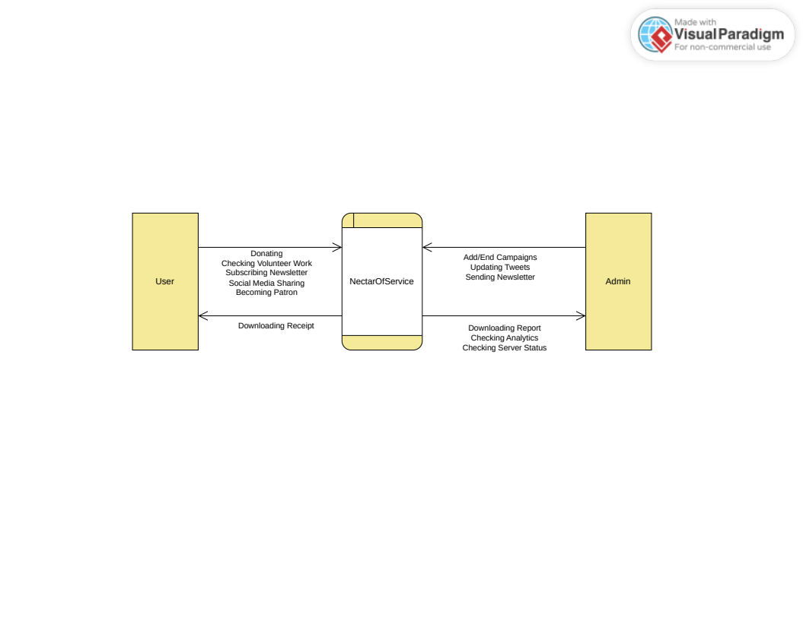

**2. Level 1 Diagram**

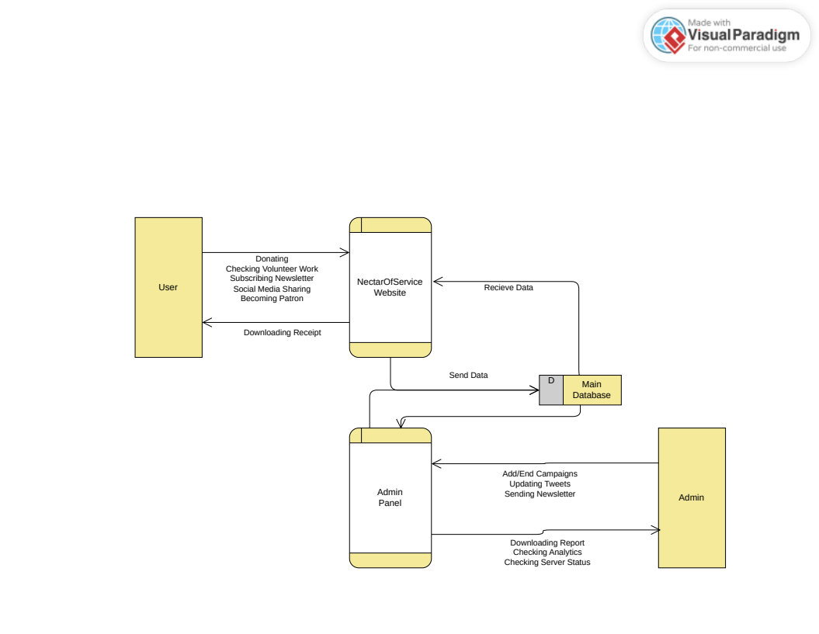

**3. Level 2 Diagram**

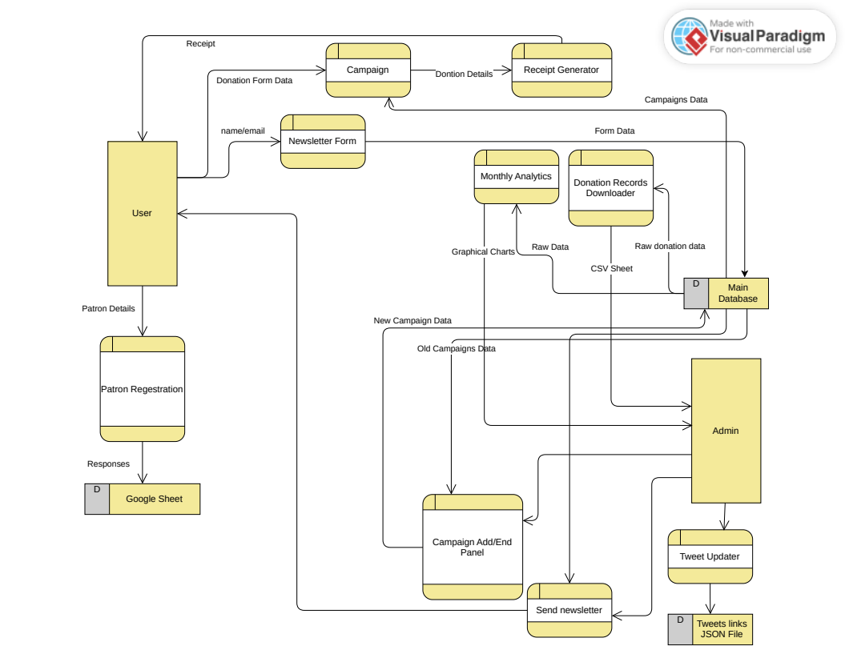

**8. E R Diagram and Database Tables**

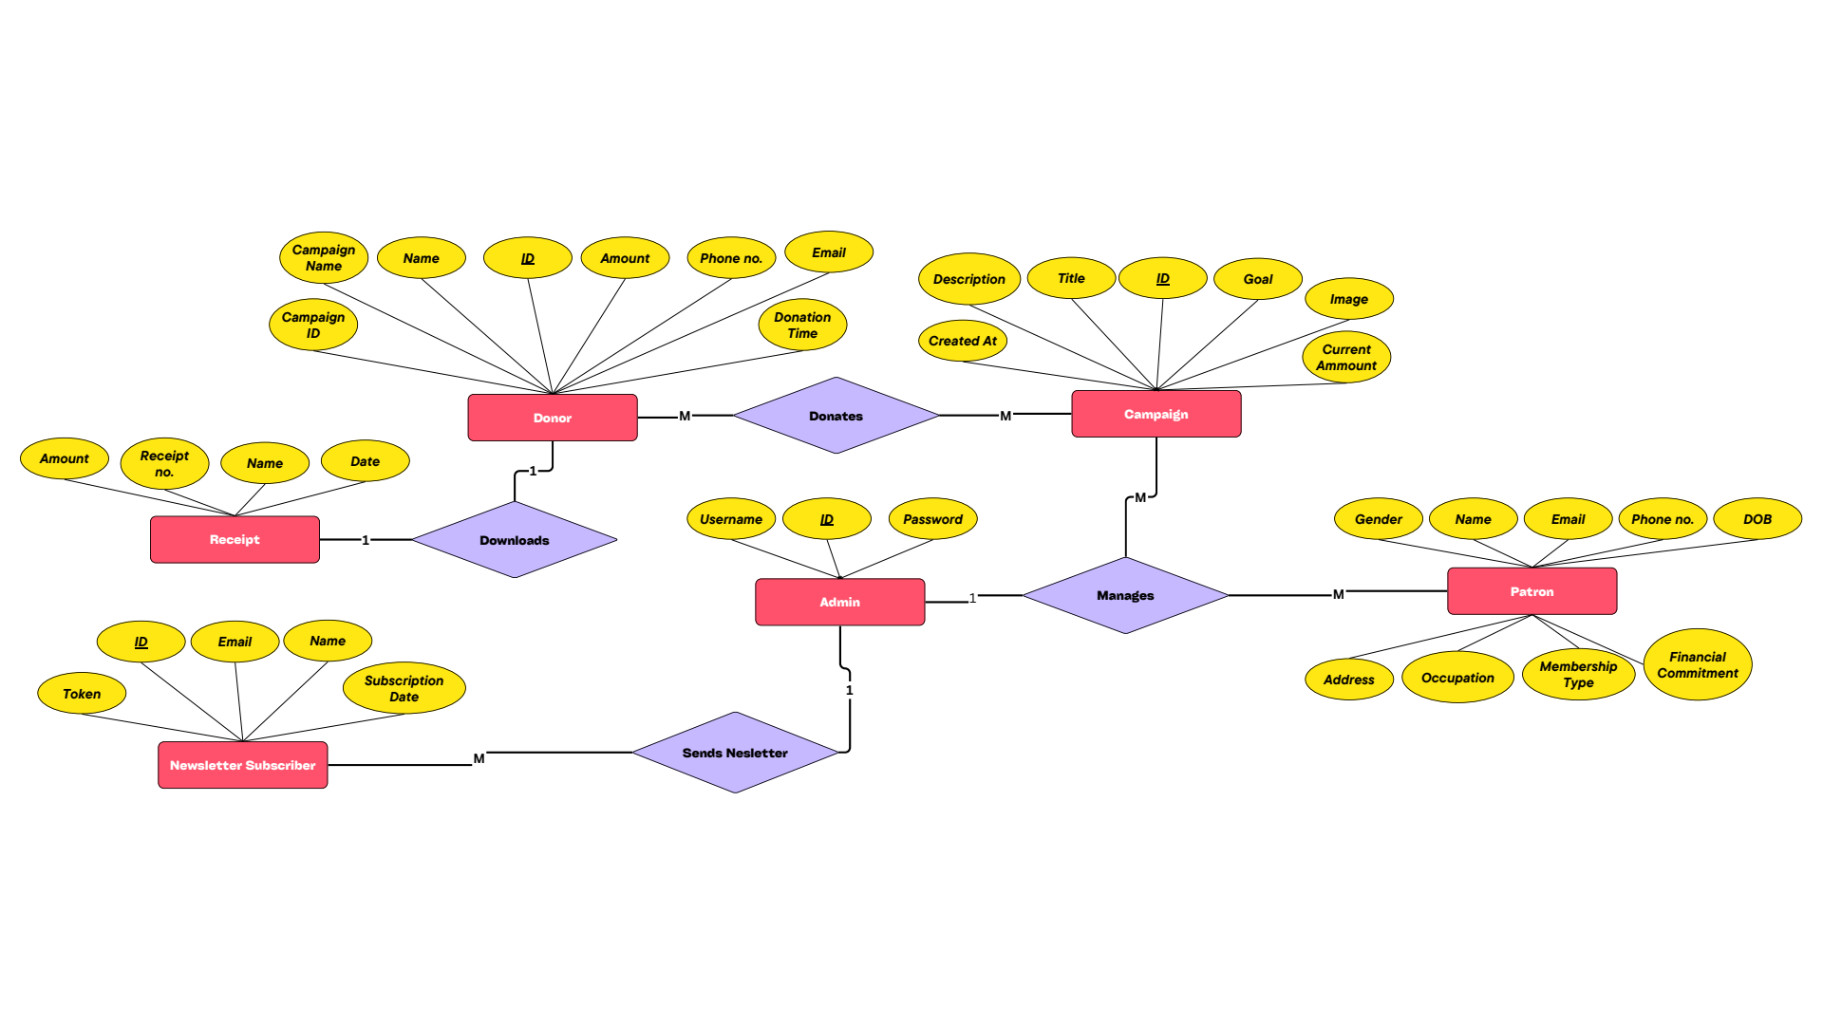

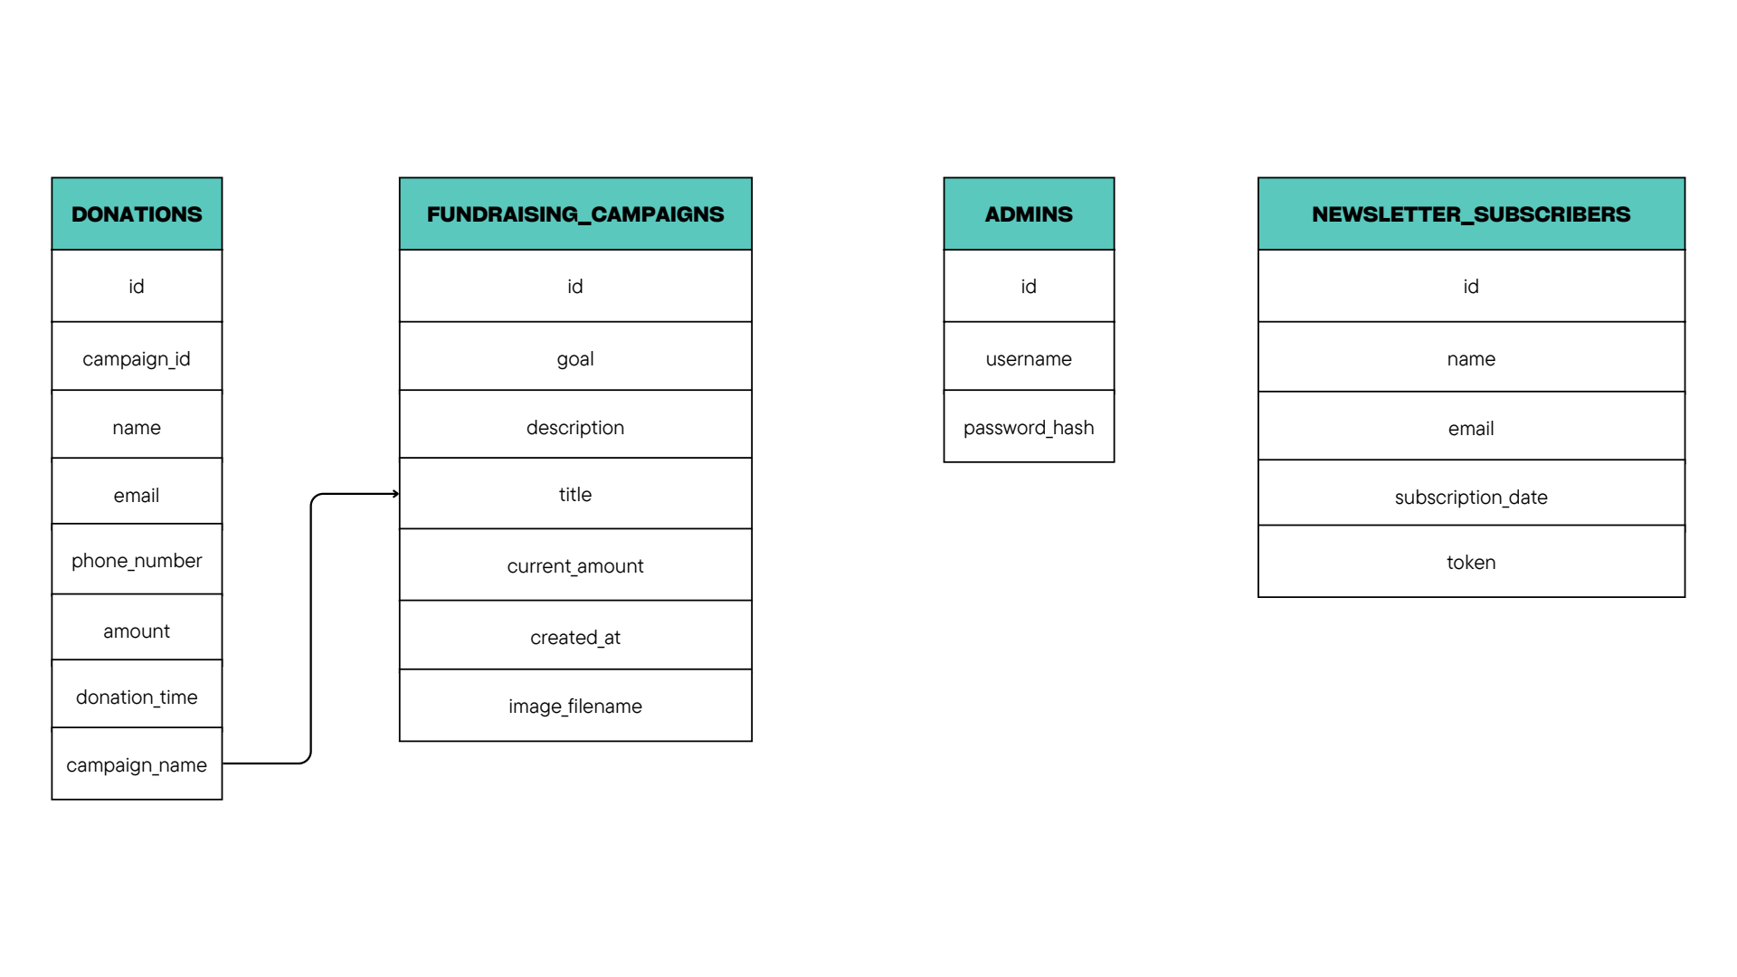

**9. Project Design (Screenshots)**

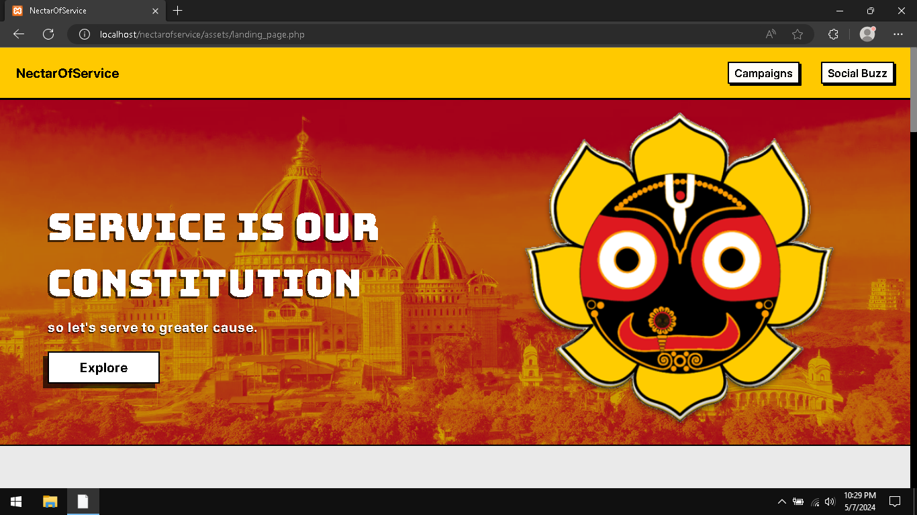  
Landing Page (Part 1): Hero Section and Navigation Bar

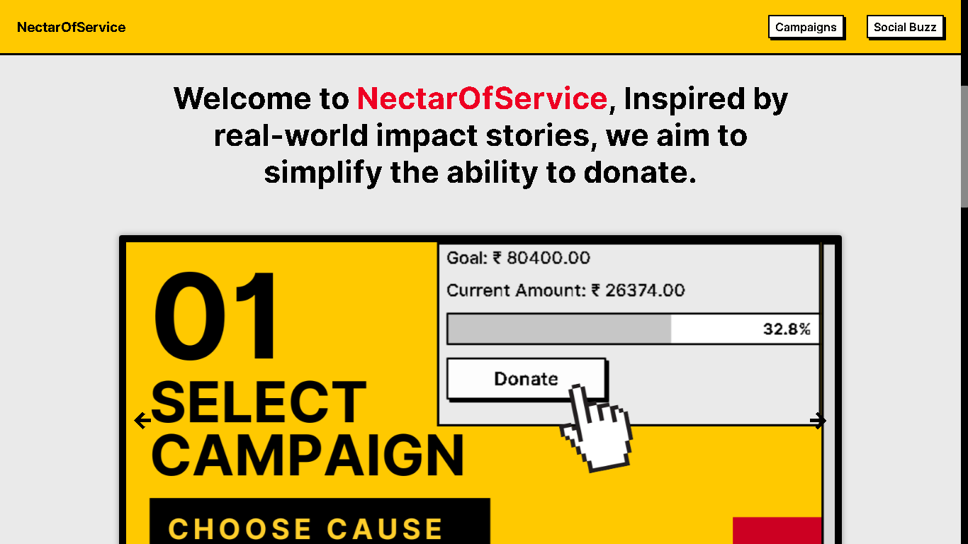  
Landing Page (Part 2): Main Section / Carousel

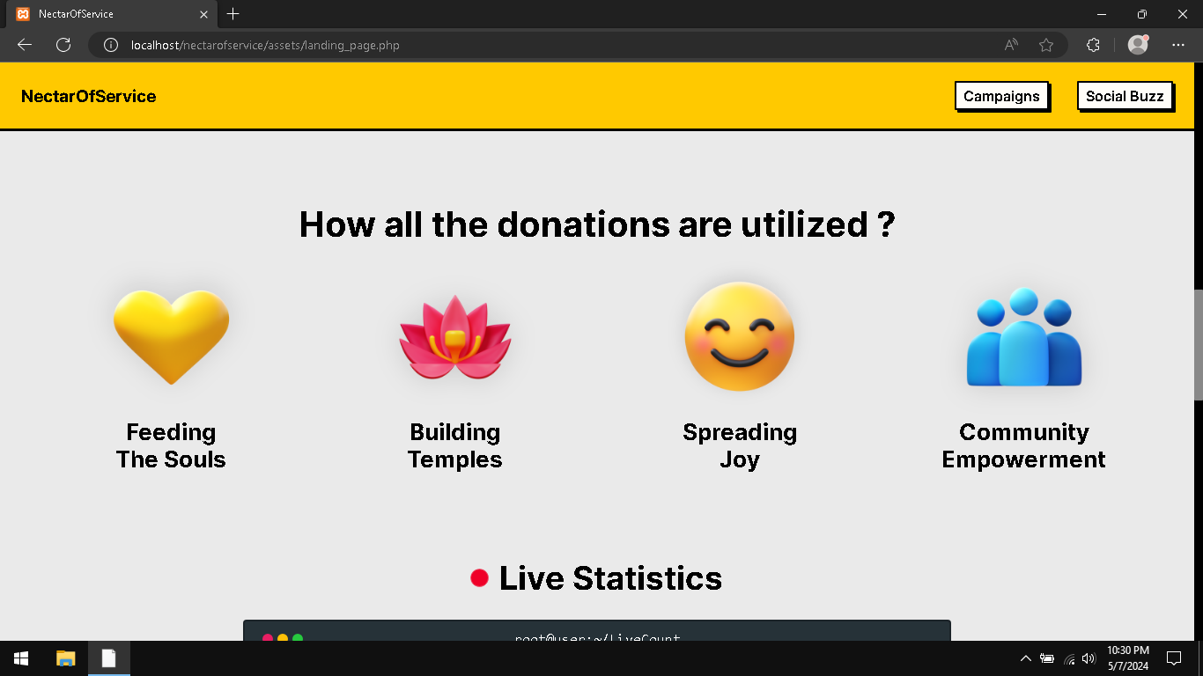  
Landing Page (Part 3)

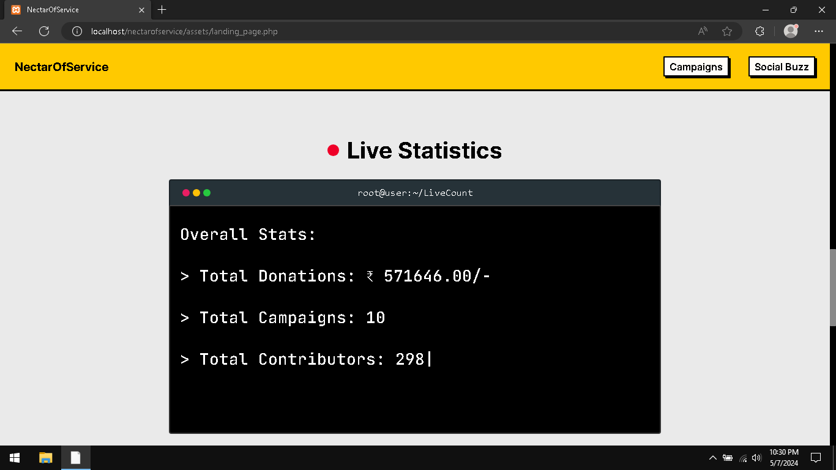  
Landing Page (Part 4): Live Statistics

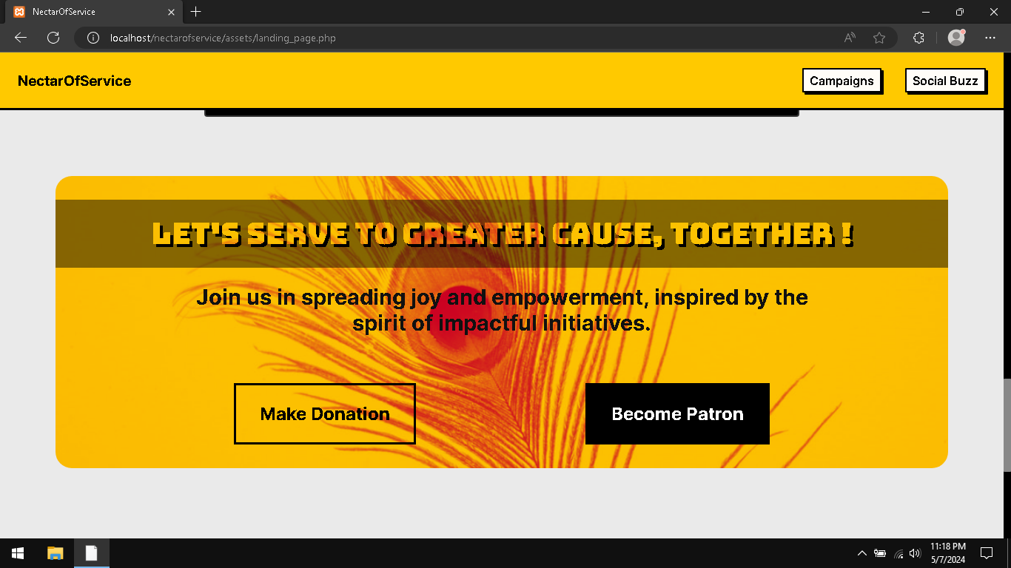  
Landing Page (Part 5): Final Call Section

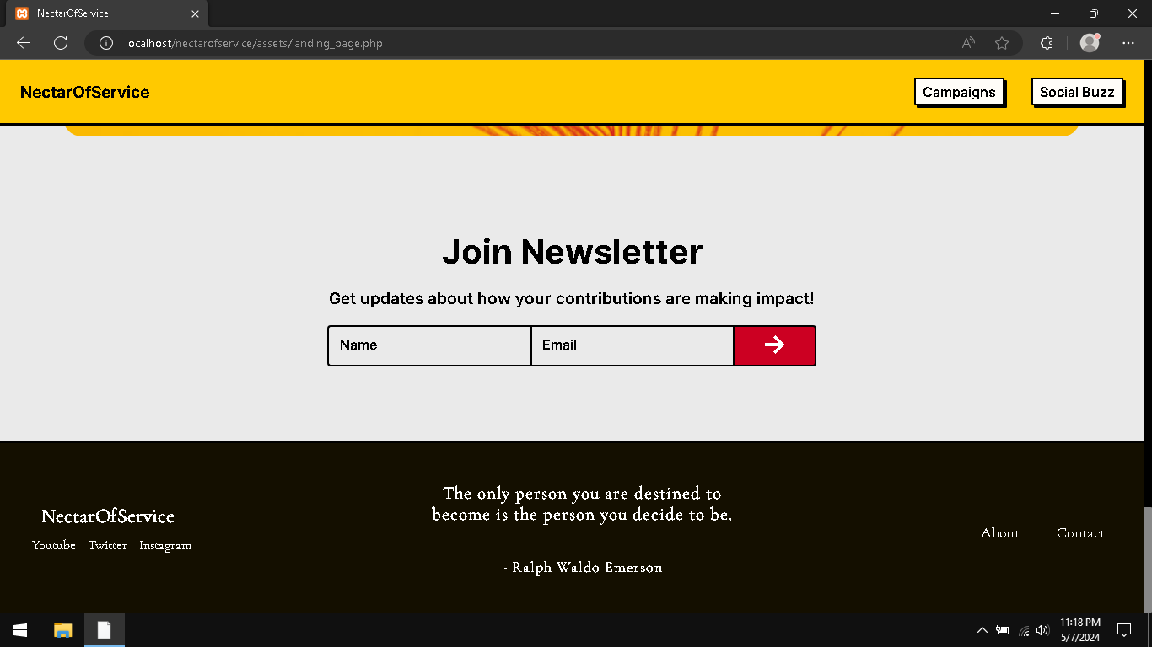  
Landing Page (Part 6): Newsletter and Footer

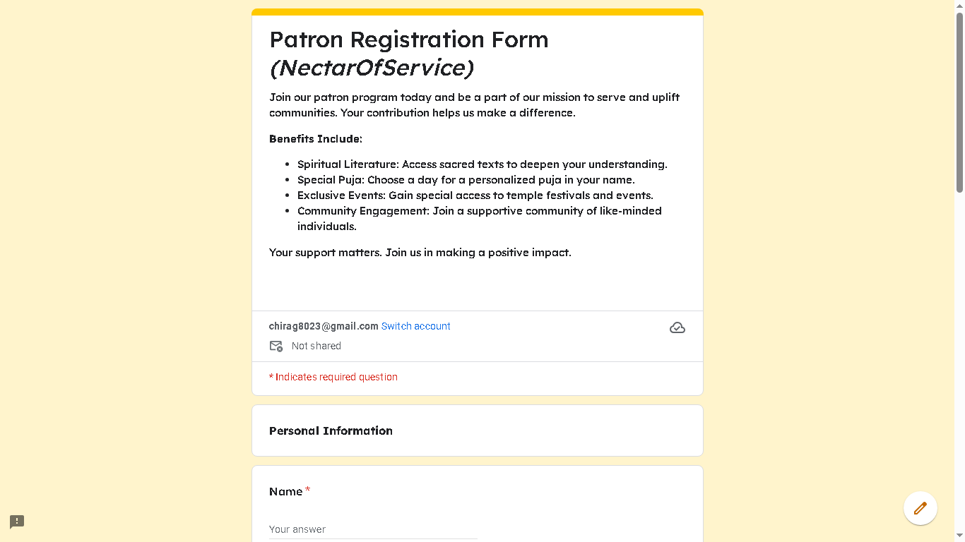  
Patron Registration Form

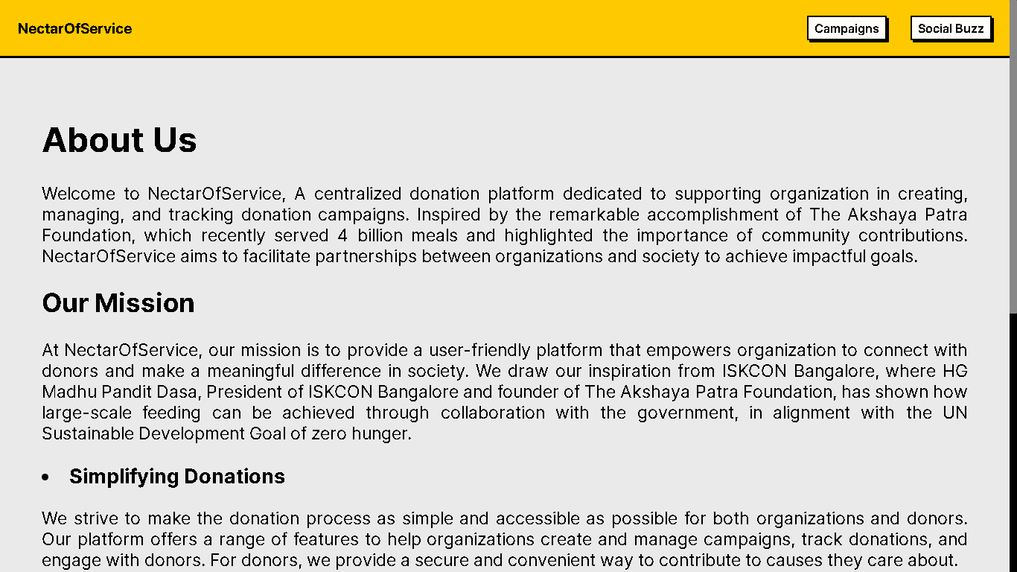  
About Us page

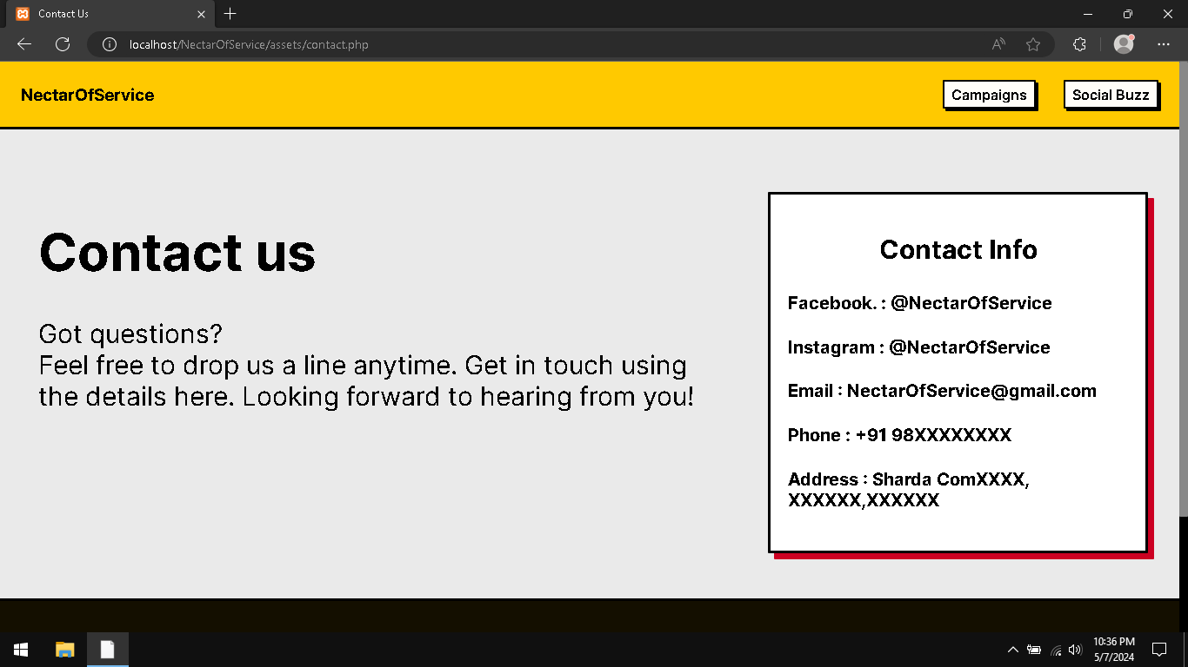  
Contact Us Page

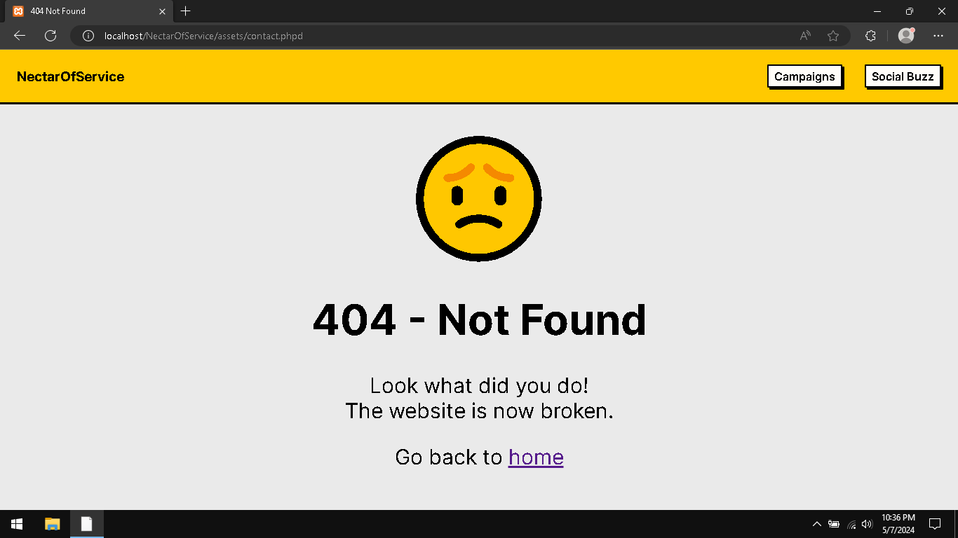  
404 Not Found Page

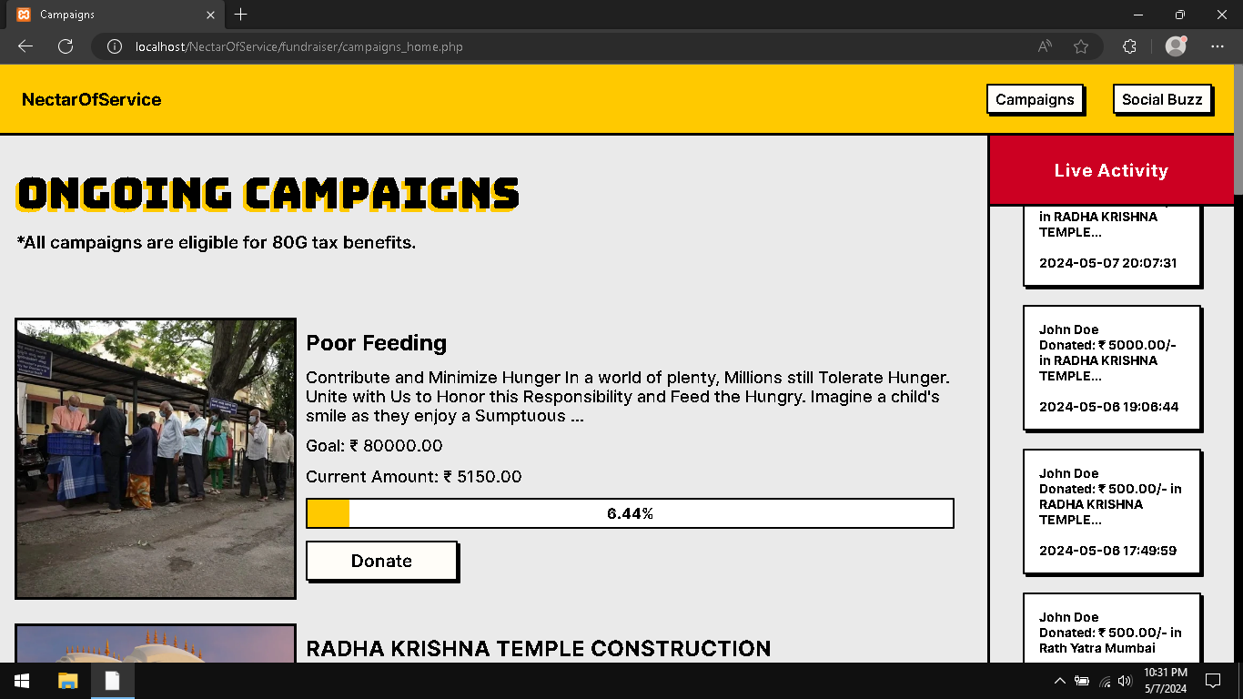  
Campaigns Page

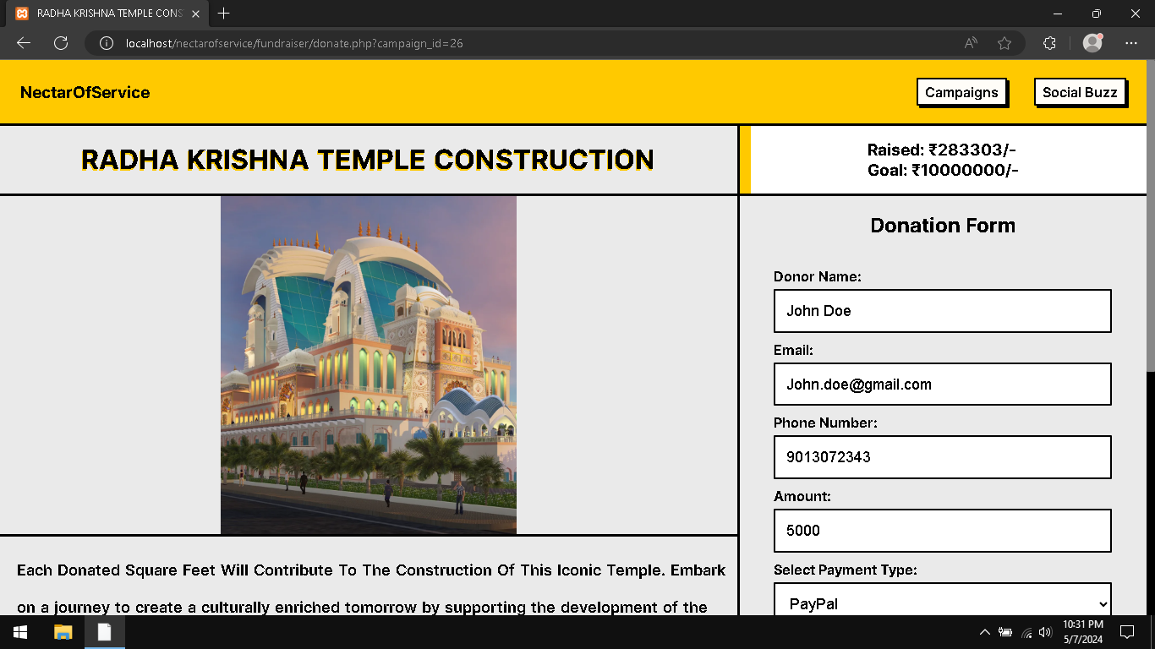  
Donation Page (Part 1)

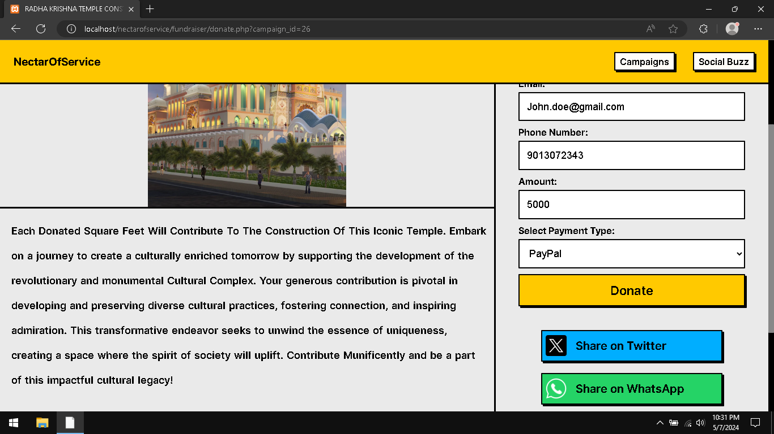  
Donation Page (Part 2)

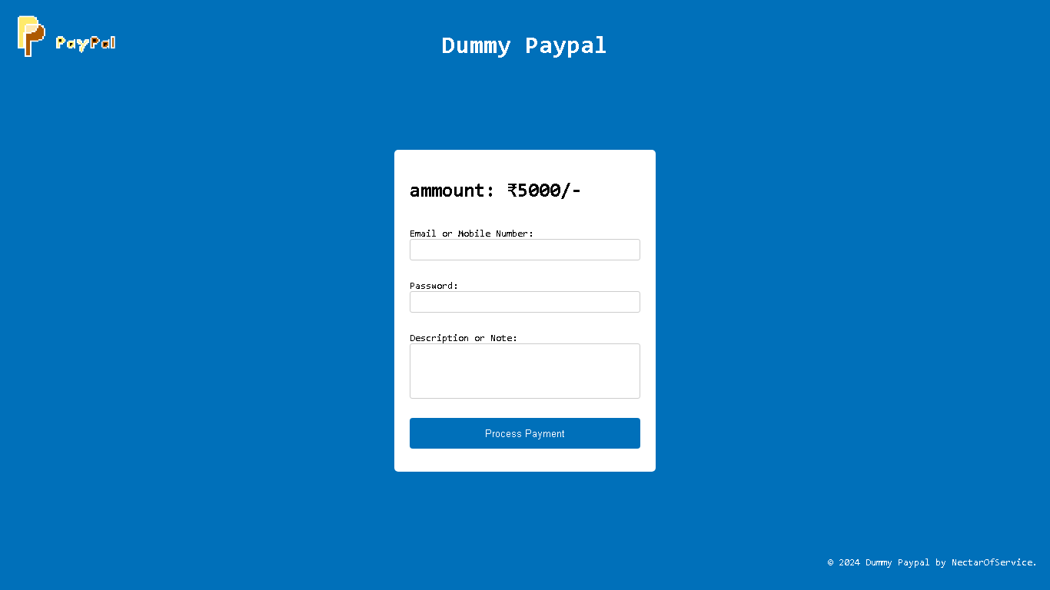  
  
Dummy Paypal Interface

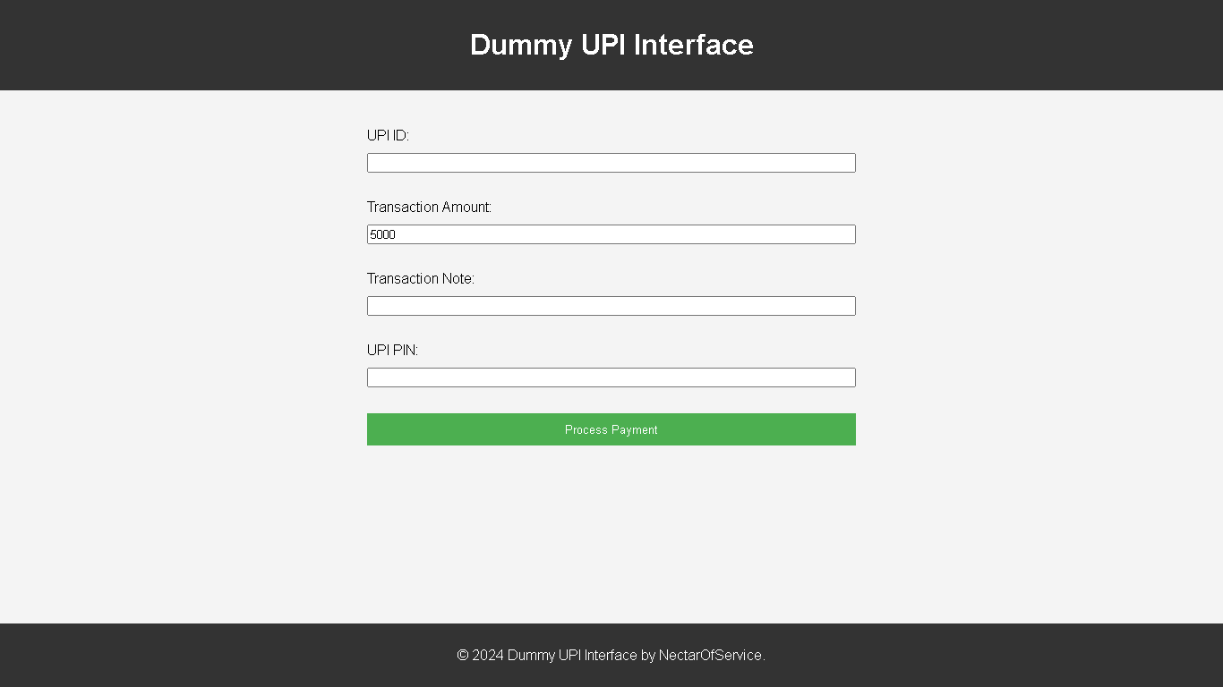  
Dummy UPI Interface

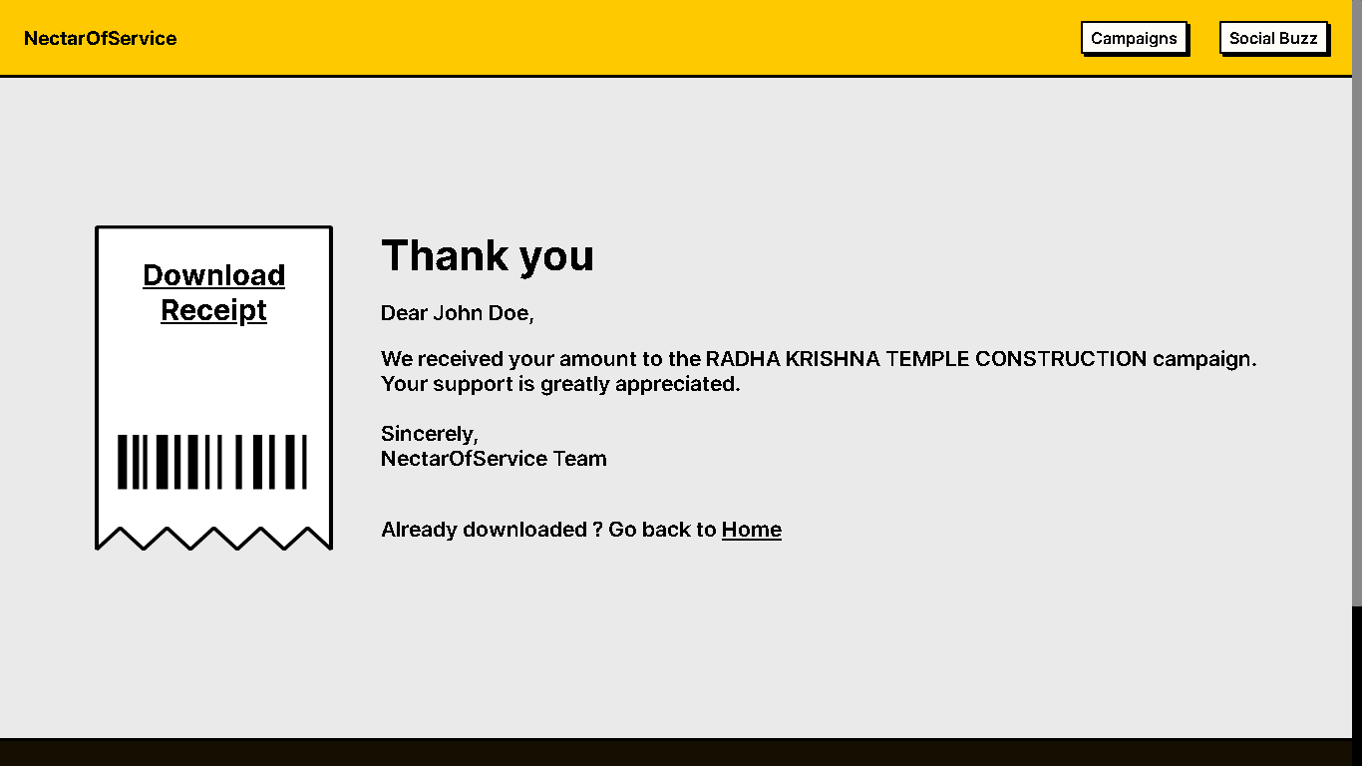  
After Donation Thank You Page

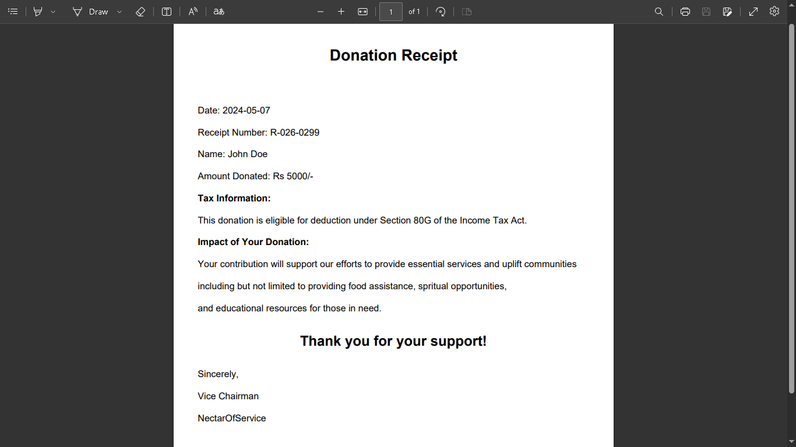  
Donation Receipt

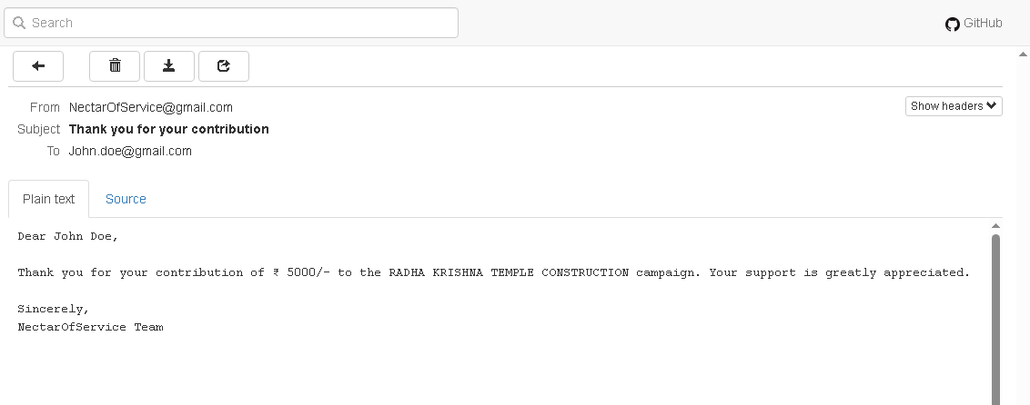  
After Donation Confirmation And Thank You Email

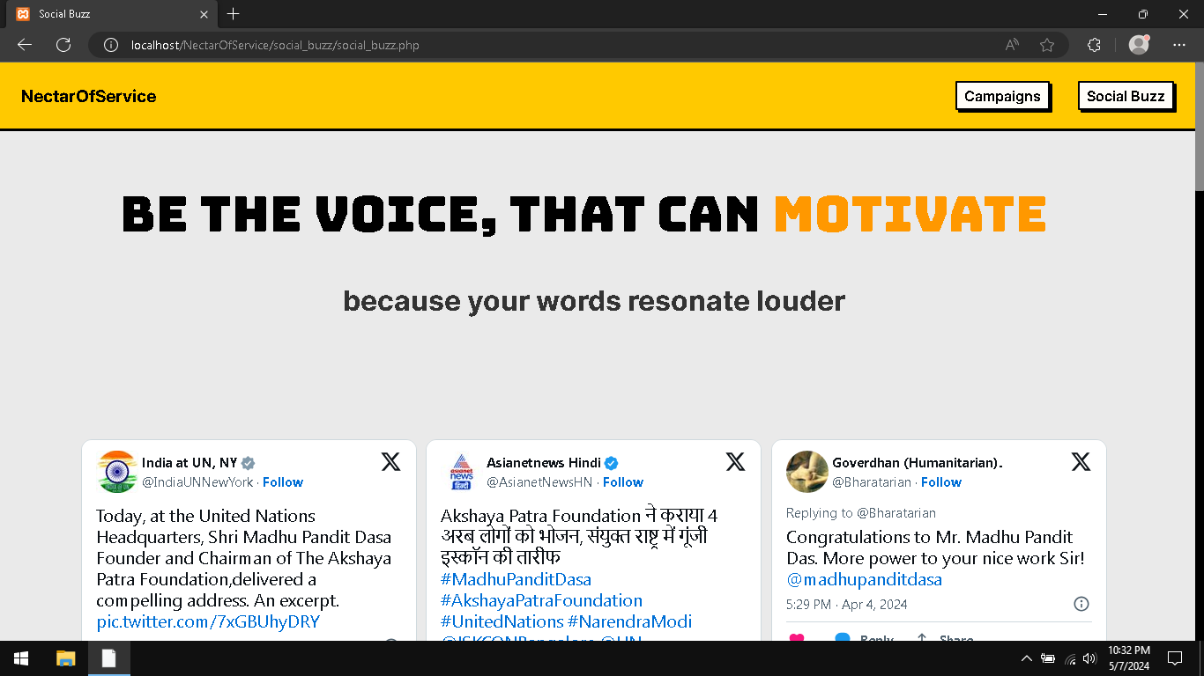  
Social Buzz Page (Part 1): Tweets

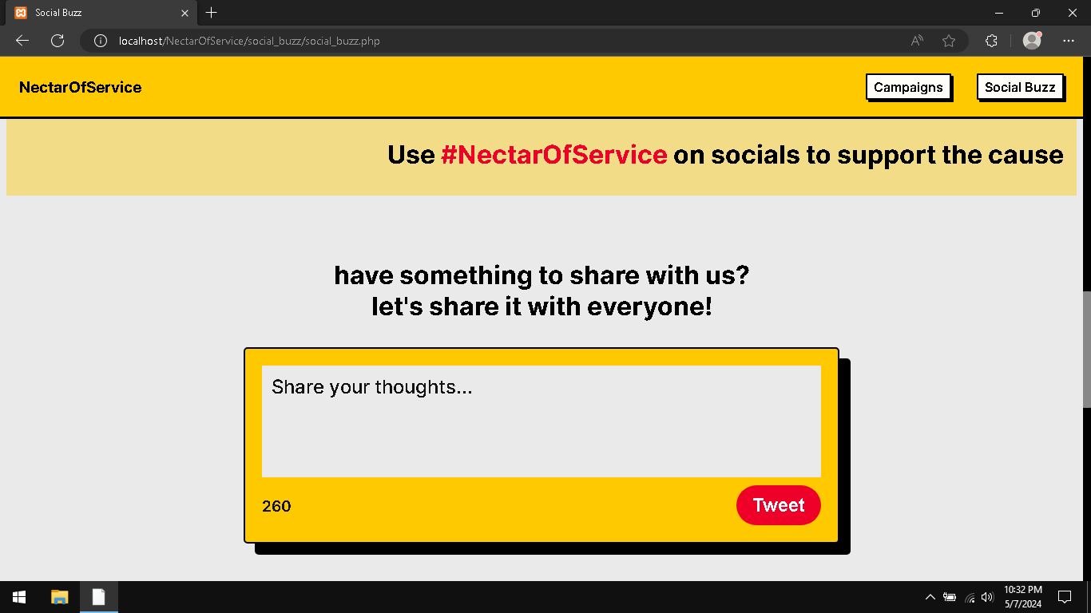  
Social Buzz Page (Part 1): Tweet Composer

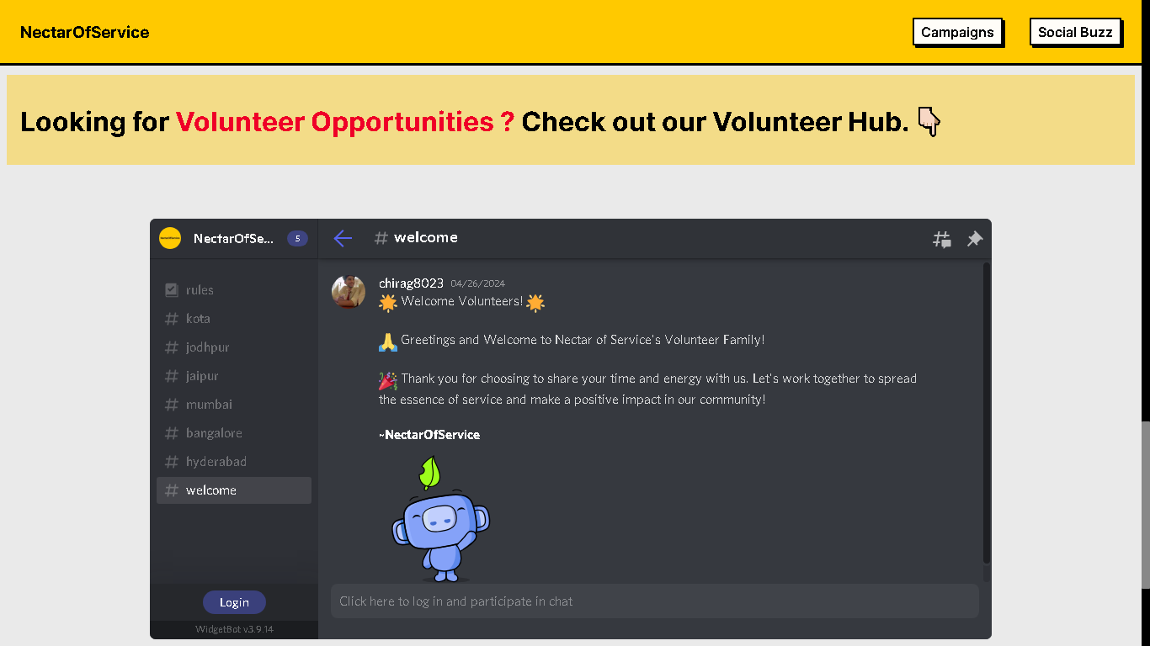  
Social Buzz Page (Part 3): Volunteer Hub Section

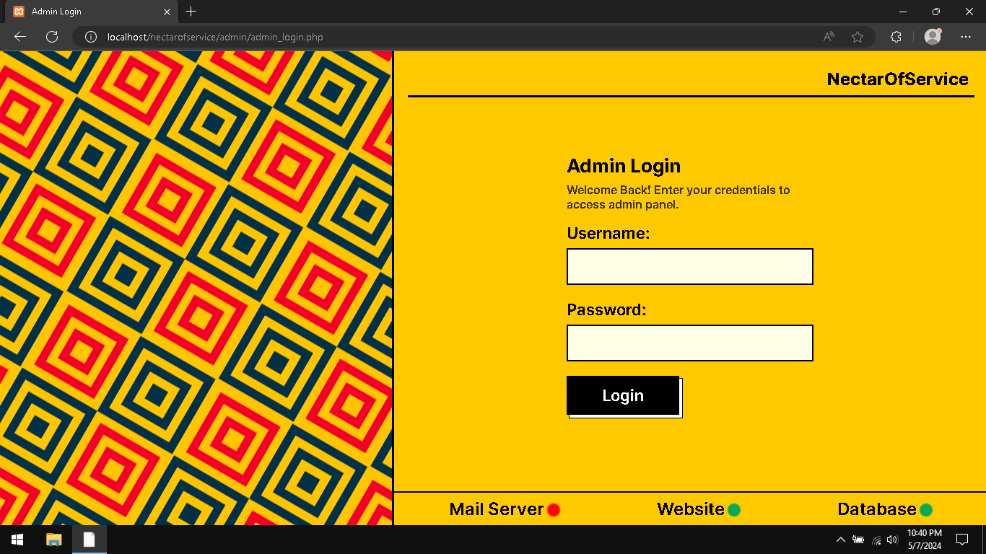  
Admin Panel Login

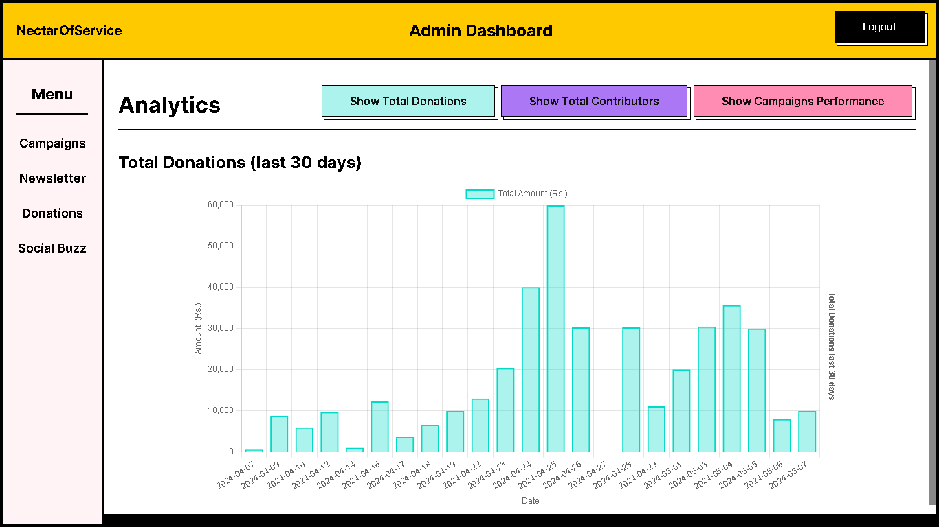  
Admin Panel Dashboard

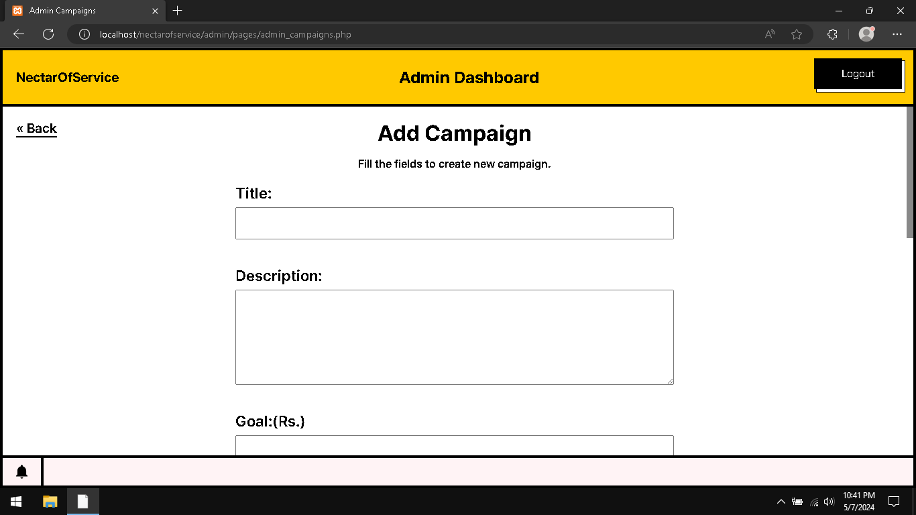  
Admin Panel Campaigns (Part 1): Add Campaigns

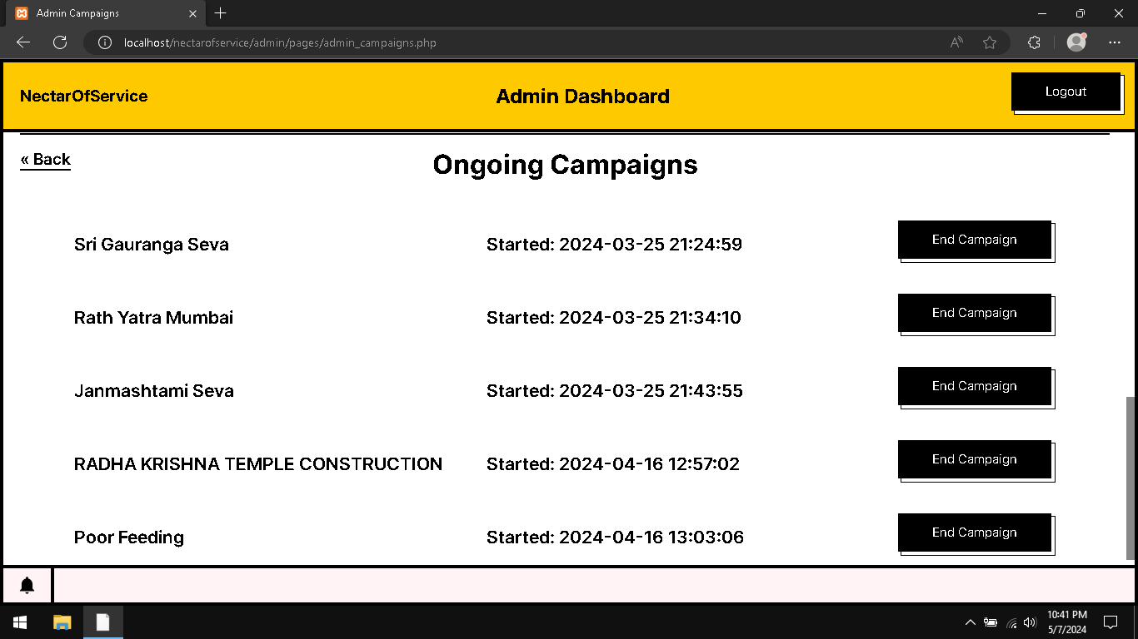  
Admin Panel Campaigns (Part 2): End Campaign

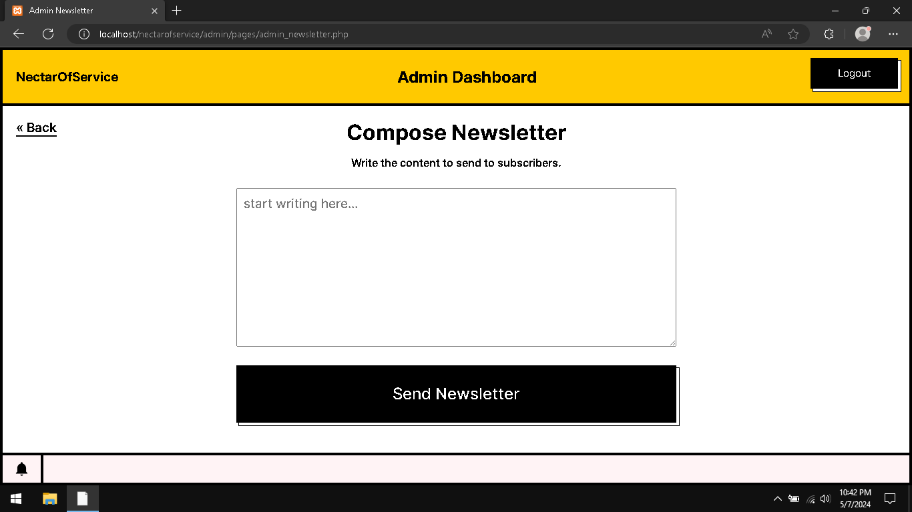  
Admin Newsletter Composer

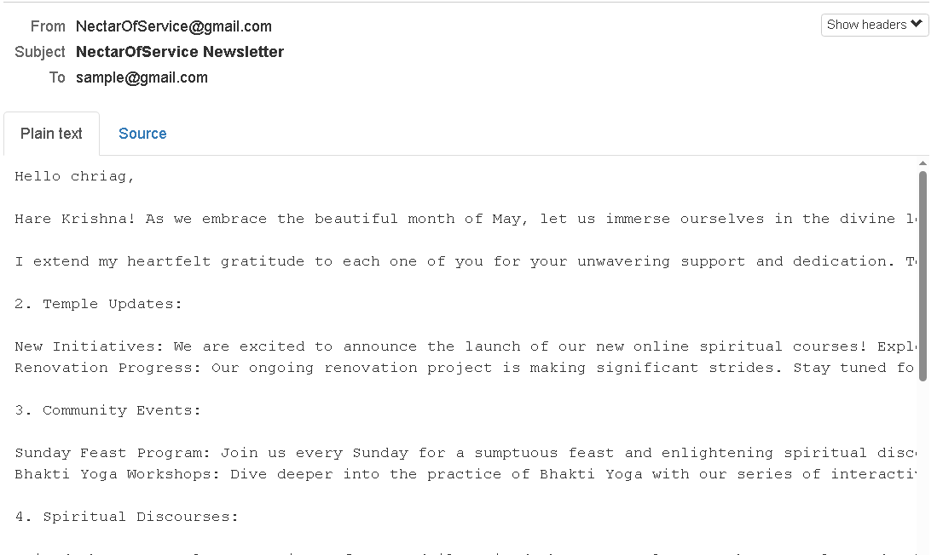  
Sent Newsletter Sample

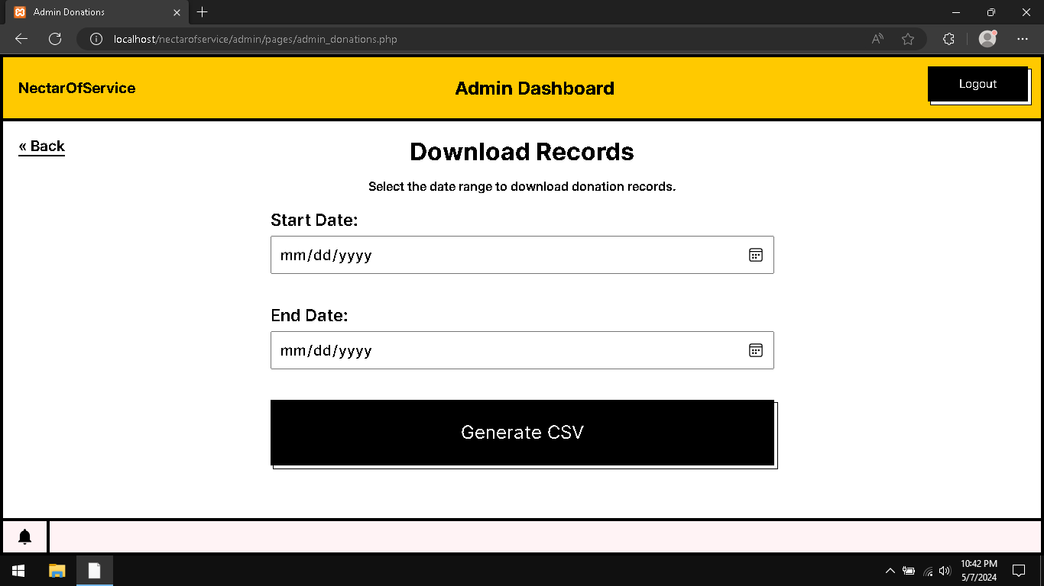  
Admin Download Donation Records

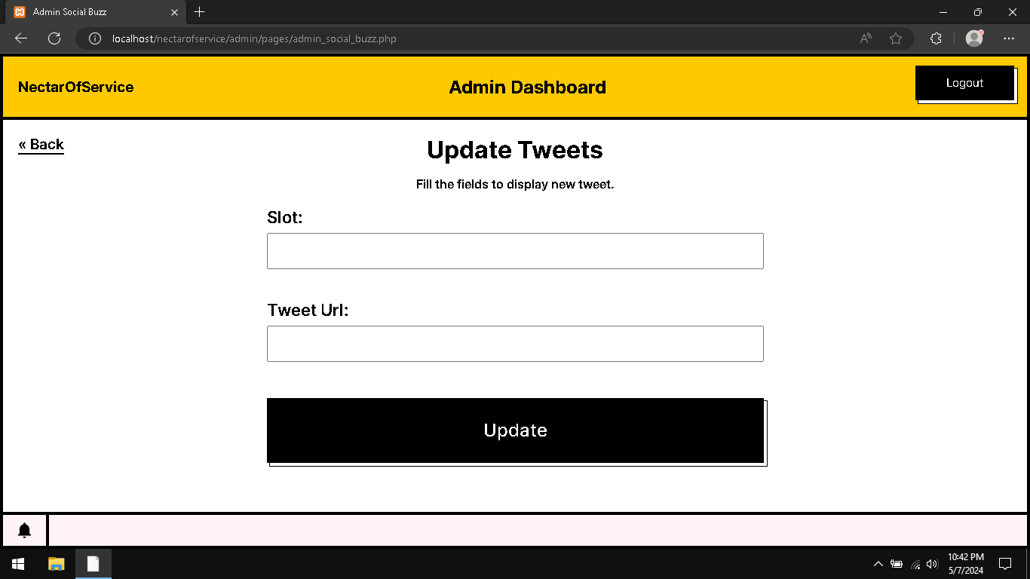  
Admin Social Buzz Tweet Updater

**10. Future Enhancements**

1. ***Enhanced Campaign Management Features:*** Introduce advanced campaign management tools such as A/B testing for fundraising strategies, customizable campaign templates, and automated campaign scheduling to streamline the process for administrators and optimize campaign performance.
2. ***Personalized Donor Engagement:*** Implement personalized donor engagement features such as donor profiles, personalized fundraising recommendations based on past contributions, and interactive dashboards to track individual impact and foster deeper connections between donors and causes.
3. ***Integration with Emerging Technologies:*** Explore integration opportunities with emerging technologies such as blockchain for transparent donation tracking and smart contracts for automated fund disbursement, enhancing trust, security, and efficiency in donation management processes.
4. ***Gamification and Rewards Programs:*** Introduce gamification elements such as leaderboards, badges, and rewards programs to incentivize donor participation, drive engagement, and recognize contributions, creating a more interactive and rewarding donor experience.
5. ***AI-Powered Analytics and Insights:*** Leverage artificial intelligence (AI) and machine learning (ML) algorithms to analyze donor behavior, predict donation trends, and generate actionable insights for campaign optimization, enabling administrators to make data-driven decisions and maximize fundraising outcomes.
6. ***Expanded Social Media Integration:*** Enhance social media integration capabilities by integrating with additional platforms, introducing social listening tools to monitor campaign sentiment, and facilitating seamless sharing of campaign updates and success stories across social networks to amplify reach and engagement.
7. ***Mobile App Development:*** Develop dedicated mobile applications for iOS and Android platforms to provide donors and administrators with convenient access to campaign updates, donation tracking, and engagement features on the go, enhancing accessibility and user engagement.
8. ***Enhanced Volunteer Management Tools:*** Expand volunteer management capabilities with features such as volunteer scheduling, task assignment, and performance tracking, empowering organizations to efficiently mobilize and manage volunteer resources for fundraising events and community initiatives.
9. ***Multilingual Support and Accessibility:*** Introduce multilingual support and accessibility features to make the platform more inclusive and accessible to diverse audiences, ensuring that users from different linguistic backgrounds and abilities can engage with the platform effectively.
10. ***Collaborative Partnerships and Integration:*** Forge strategic partnerships with other organizations, crowdfunding platforms, and payment gateways to expand the platform's reach, leverage complementary resources, and facilitate seamless integration with external systems, enhancing interoperability and scalability.

These future enhancements aim to elevate the "Nectar Of Service" platform to new heights, enriching the user experience, expanding functionality, and maximizing its impact in driving positive social change. By embracing innovation and continuous improvement, the platform remains poised to address evolving donor needs and societal challenges effectively.

**11. Conclusion**

In conclusion, "Nectar Of Service" represents a pioneering initiative poised to revolutionize the landscape of charitable giving and community engagement. Through meticulous planning, innovative design, and collaborative efforts, we have created a dynamic digital platform that empowers organizations and individuals to make a tangible difference in the world.

Our journey began with a recognition of the pressing need for a modern, centralized hub for managing and monitoring donation campaigns. Inspired by the impactful initiatives of esteemed organizations like ISKCON Bangalore and The Akshaya Patra Foundation, we embarked on a mission to redefine the dynamics of charitable giving and amplify the impact of collective efforts.

Throughout the development process, we remained steadfast in our commitment to excellence, leveraging cutting-edge technologies and best practices to deliver a robust and user-friendly platform. From intuitive campaign management tools to personalized donor engagement features, every aspect of "Nectar Of Service" has been meticulously crafted to enhance user experience and drive meaningful social change.

Moreover, our project embodies the spirit of collaboration and inclusivity, fostering partnerships, and empowering communities to come together in service of common goals. By providing a platform for transparent communication, active participation, and collective action, we aim to inspire a culture of compassion, unity, and social responsibility.

As we reflect on our journey and look towards the future, we recognize that our work is far from complete. There are still countless opportunities for growth, innovation, and impact waiting to be explored. With a steadfast commitment to continuous improvement and a shared vision of a more just and equitable world, we remain dedicated to advancing the mission of "Nectar Of Service" and making a lasting difference in the lives of those in need.

**12. References**

https://codepen.io/

https://dribbble.com/

https://www.awwwards.com/

[https://fonts.google.com](https://fonts.google.com/)/

[https://harekrishnajaipur.org](https://harekrishnajaipur.org/)/

<https://lawsofux.com/>

https://developer.mozilla.com/

https://www.canva.com/

https://www.producthunt.com/

https://icons8.com/

https://landingpagesexplained.com/

https://www.colorhexa.com/

**Appendix**

***Appendix A:*** Technical Specifications

* Frontend: HTML5, CSS3, JavaScript
* Backend: PHP, MySQL
* Development Environment: XAMPP

***Appendix B:*** Glossary of Terms

* XAMPP: Local web development environment.
* PHP: Server-side scripting language.
* MySQL: Relational database management system.
* MailHog: Email testing tool.
* API: Application Programming Interface.
* Apache: An open-source web server software.
* Responsive Design: An approach to web design that makes web pages render well on a variety of devices and window or screen sizes.
* UI: User Interface, the means by which a user interacts with a computer, website, or application.
* UX: User Experience, the overall experience of a person using a product such as a website or computer application, especially in terms of how easy or pleasing it is to use.
* CSV: Comma-Separated Values, a delimited text file that uses a comma to separate values.
* FPDF: Free PDF Generation Library for PHP.
* JSON: JavaScript Object Notation, a lightweight data interchange format.
* Session: A way to persist data across multiple page requests.